Coronavirus
(COVID-19)
Self- Help Booklet
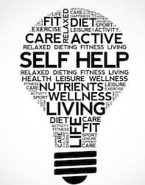


COVID-19 is dominating headlines across the world. We want you to understand the importance of staying safe during this difficult and uncertain time.
What is Covid-19?
COVID-19 is a new disease that affects your lungs and airways, it is highly contagious and can be deadly.
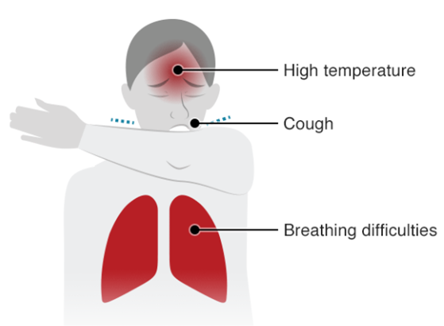
The Symptoms of COVID-19
- Fever
- Dry and continuous cough
- Tightness of chest


What to do if you develop these symptoms?
- Visit www.nhsdirect.wales.nhs.uk/SelfAssessments/symptomcheckers
- Call 111 and follow advice given
- Stay at home do not visit GP, Pharmacy or Hospital!!
- You will need to self-isolate for 7 days and if there are family members with you they need to isolate for 14 days.
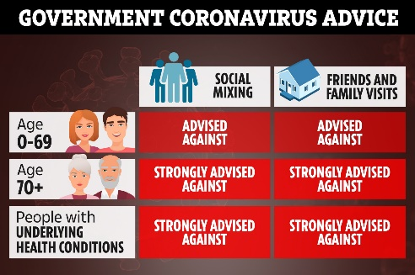
Vulnerable category
If you fall under the vulnerable category the government has advised for you to stay in doors for 12 weeks due to the higher risk of catching COVID-19. You must adhere to these guidelines if you:
- Are over 70 years of age
- Are pregnant
- If you have underlying health conditions such as:
- Diabetes
- Autoimmune system disease
- Suffer from any type of lung condition – COPD, lung cancer
- Receiving cancer treatment
- Have had an organ transplant
- Taking any medications that weaken your immune system

How to protect yourself from COVID-19
- Only leave the house for necessities, for example food!
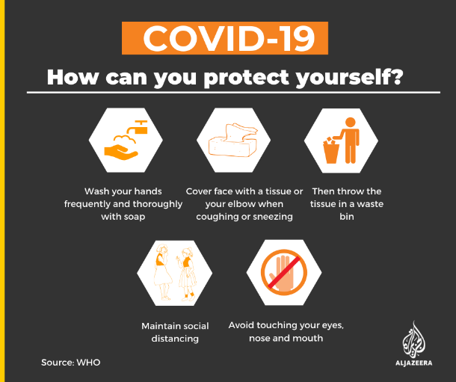
- Only leave the house once a day if needed for example to go to the supermarket or for one form of exercise
- When out in public remember social distance – 2 metres away at all times!
- Avoid touching your face, eyes, mouth and nose
- Wash your hands regularly for 20 seconds – use the happy birthday song to count this!
- Regularly disinfect surfaces for example: door handles, phones, kitchen units
- If you do cough, cough into the bend of your elbow
- Avoid individuals in vulnerable category
- If you feel unwell please stay at home and contact 111
- If you develop symptoms please self-isolate for 7 days and if you come into contact with other individuals they must self-isolate for 14 days.

Government Guidelines
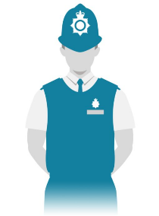
THE POLICE WILL FINE YOU IF YOU ARE NOT ADHERING TO THESE GUIDELINES
- Public gatherings of 2 or more people are banned
- Only leave to house if it is necessary to go to work or to gather essentials
- One form of outdoor exercise a day
- Staying at home is absolutely necessary
- Do not to travel to other households or socialise outside your house

How to cope during this uncertain time
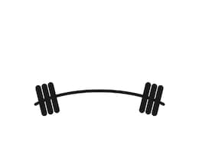
It is important we remain positive and focused during this uncertain time and remember it is only temporary. It is important to keep yourself, mind, body and soul active and highlight the importance of self-care on yourself and others.
Keeping Active
The gym closed? No problem
- Keep active for an hour a day! Go for a walk, run, cycle in the fresh air – remember keep social distance!
- Complete a home workout online – many social media sites are providing free home workouts that are only 10 minutes long!
- Try youtube – Joe Wicks the Body Coach, Alice Living or just type in an exercise you would like to do!
- Go for a walk in the garden – take in the fresh air
- Do some yoga
- Try this simple workout at home with no gym equipment needed:
- 20 jumping jacks
- 20 high knees
- 20 mountain climbers
- 20 squats
Repeat 4 times with a 10 second break in between!
Self-Care
The most important factor is to look after yourself and others surrounding you, remember to take part in self-care for yourself and loved ones!

- Pamper yourself, have a pamper day at home and get the household involved
- Put your favourite TV programme or film on
- Listen to your favourite music
- Take 5 minutes out for yourself and have some alone time
- Have a nice warm bath
- Make your favourite dinner
- Talk to friends
- Reminisce on old memories that make you laugh and smile
- Look through old photographs
- Move your body!
- Plan your next adventure

Managing anxiety in this difficult time
Suffering from a feeling of worry, nervousness, unease and confusion?
These feelings are going to imminent the next few weeks and if you do already suffer with anxiety these will be heightened due to the unknown.
However, we can help deal with these feelings:
- Talk to someone, gather an understanding of what is going on and remember you are not alone!
- Write your feelings down
- Take a step away from social media and the news until you gather control over your feelings
- Go for a walk, run of get some fresh air! Even just being outside will work wonders for you.
- Take part in some exercise, increase your endorphins! They make you feel good!
- Take part in some mindfulness activities: Muscle relaxation, breathing techniques.
- Distract yourself – take part in a preferred activity, make a cup of tea and take a 5 minutes break!


Mindfulness Activities:
Breathing exercises: Blowing out the candle
- Sit down
- Think of your favourite smell – food, perfume, environment
- Imagine breathing in that smell
- Take a deep breath in and hold for 2 seconds -1,2
- Then exhale for 4 seconds – 1,2,3,4

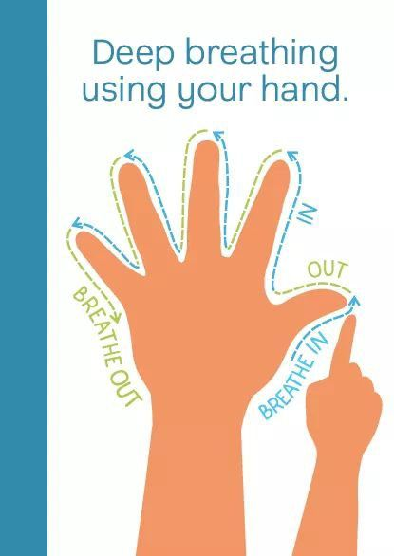
Deep breathing using your hand:

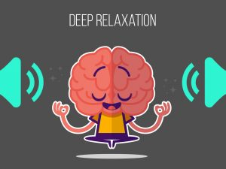
Progressive Muscle Relaxation
- Practise for 15 minutes a day
- Sit in a comfortable chair
- Hold tension for 5 seconds
- Let go and relax muscles for 10 seconds
1).Take a deep breath in, hold for a 3 seconds and breathe out
2).Clench the right fist, feeling tension in the fist and arm.
3).Clench the left fist, feeling the tension in the fist and arm.
4). Make a frown on your face, feel the tension around your eyes.
5).Tense your jaw by biting your teeth together, feel the tension around your mouth.
6).Push your chin down onto your chest, feel the tension on your throat.
7).Push your shoulders up towards your ears, feel the tension in your shoulders
8).Push your shoulders towards the ears and circle the shoulders.
9).Breath in your stomach muscle, feel the tension in your stomach
10).Press your heels to the floor keeping the legs straight, feel the tension in your calves
11).Then press your feet and toes downwards, feel the tension in your legs.
Continue breathing calmly and repeat


Mindfulness colouring worksheets:
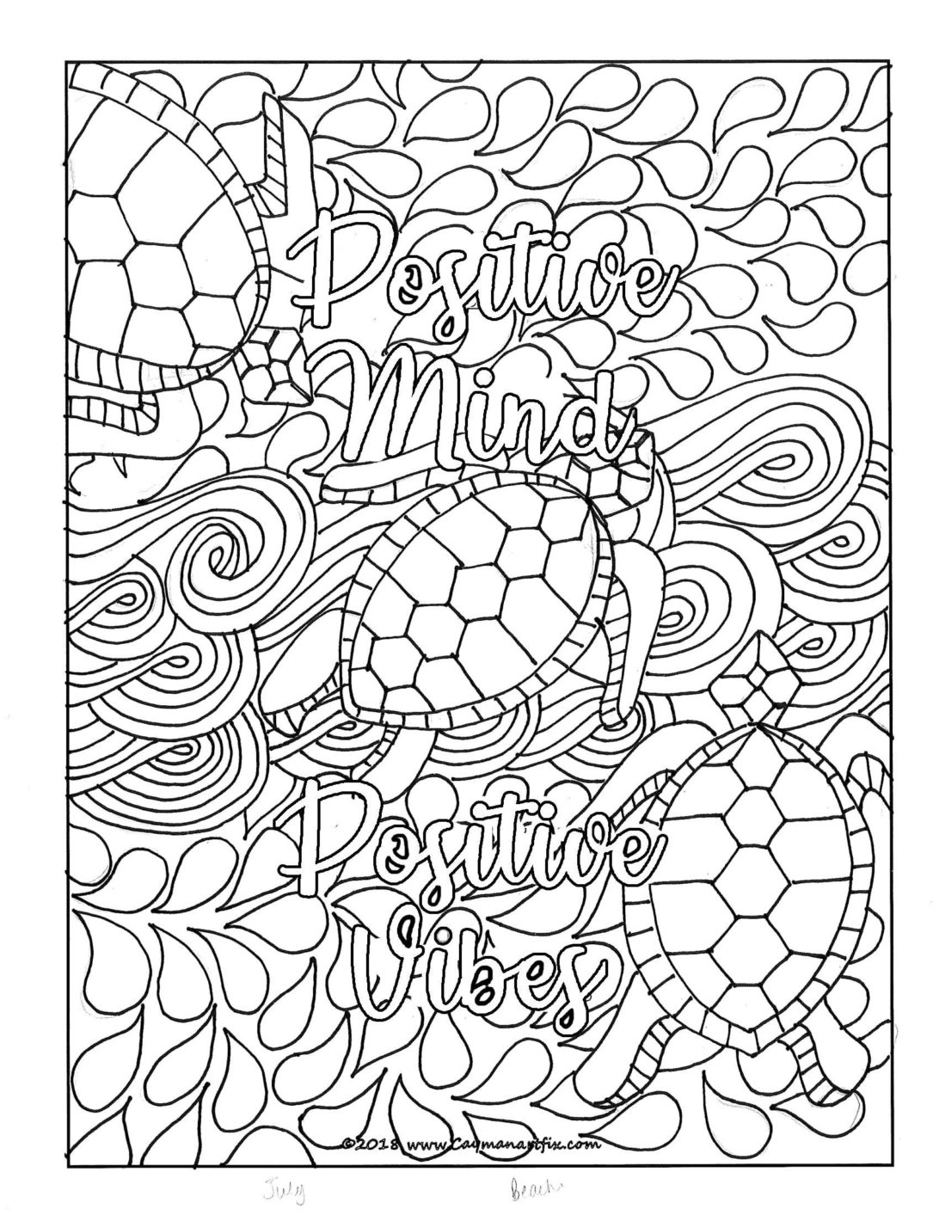


Distraction Techniques:

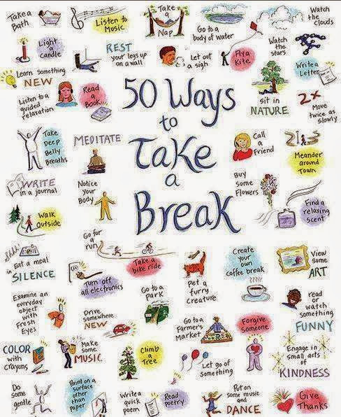

Word Searches and Crosswords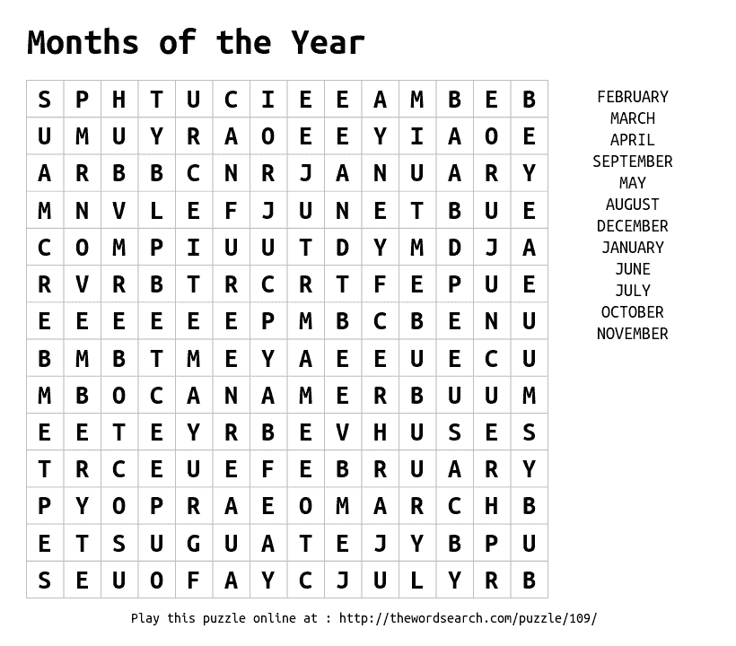
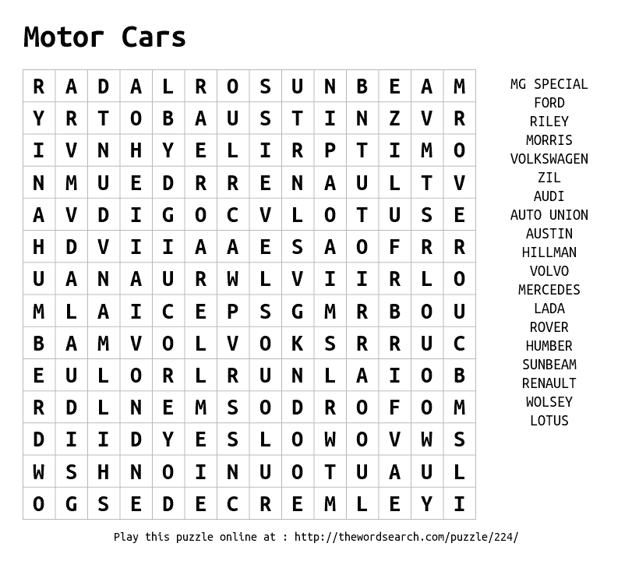
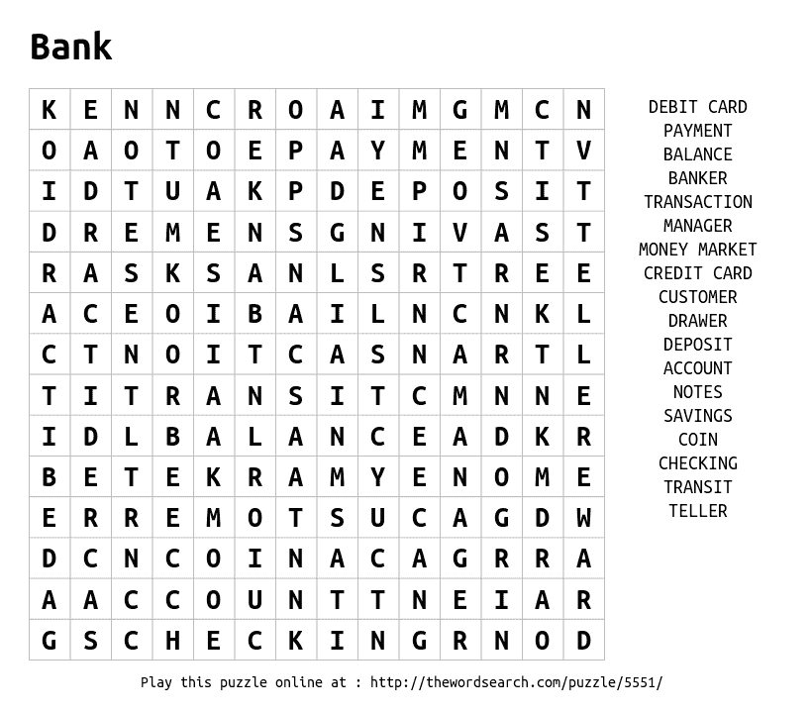

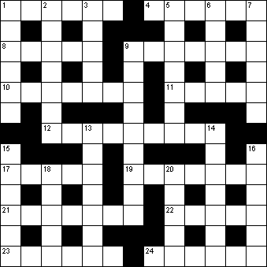
Across  1 Self-centred person (6)  4 Prepared for publication (6)  8 Cause of vexation or irritation (5)  9 Sumptuous meal (7)  10 Surgeon's knife (7)  11 Thoughts (5)  12 Recovering readily from adversity (9)  17 Ransack (5)  19 Unbeliever (7)  21 Country formerly part of Yugoslavia (7)  22 Fallacious (5)  23 Happening without warning (6)  24 Requiring immediate attention (6) | Down  1 Uncover (6)  2 Alfresco (4-3)  3 Rams and ewes (5)  5 Tooth material (7)  6 Agreement to suspend fighting (5)  7 Loathe (6)  9 Russian stringed instrument (9)  13 Ghost (7)  14 Immature toad or frog (7)  15 Summary (6)  16 Burning (6)  18 Deluge (5)  20 Not so many (5)

Across  1 Curved structure (4)  3 Pre-dinner drink (8)  9 Chewy sweet (7)  10 Composer of La Traviata (5)  11 Mar (5)  12 Lever for turning a rudder (6)  14 Something strange (6)  16 Pandemonium (6)  19 Three-legged stand (6)  21 Confronted (5)  24 Proclamation (5)  25 Chivalrous, dashing (7)  26 Roasting (anag.) (8)  27 Aspersion (4) | Down  1 Forebear (8)  2 Freight (5)  4 Courteous (6)  5 Competitor (5)  6 Underwater projectile (7)  7 Equitable (4)  8 Charm (6)  13 One to whom money is owed (8)  15 Beloved (7)  17 Nonsense (6)  18 Proverbs (6)  20 Donned (3,2)  22 Swimming stroke (5)  23 Nil (4)


Working from home and struggling?
Are you finding it difficult to work at home as it is out of your normal routine?
Remember to:
- Plan and structure your day
- Stick to routine – wake up, shower, breakfast, start work
- Maintain your usual work pattern if you can
- Set objectives for the day to keep you focused
- Remove all distraction items, i.e mobile phone
- Keep in contact with your colleagues through- phone calls, face time, zoom, video calls and google meet/hangouts

- Remember to remain health and safety aspects around your work station at home!
Children at home?
Are your children confused and worried about what is going on? Or acting out of character due to being out of routine? We understand it is harder to communicate to younger ones about any uncertain situation. However try to:
- Create a booklet to go through with them at home which provides an explanation through simple pictures
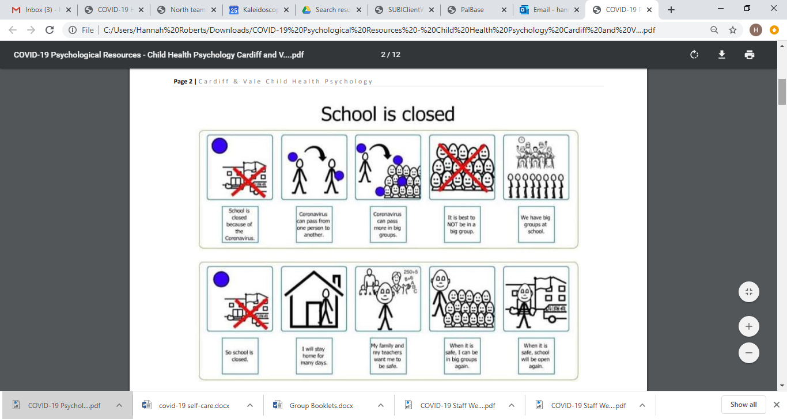

- Sit down and talk to them
- Reassure and remind them this is only temporary
- Keep them busy! Set a routine and structure for them to follow this may minimise behaviour
- Get creative! – create glitter bottles to help them to show there emotion or improvise making home musical instruments!
- Keep them active! – The body coach is doing live PE workouts from home at 9am every morning via social media websites – Youtube, Instagram
- Here is the direct link to body coach workouts –
https://www.youtube.com/watch?v=K6r99N3kXME
- Remember to Prepare, Plan, Routine!
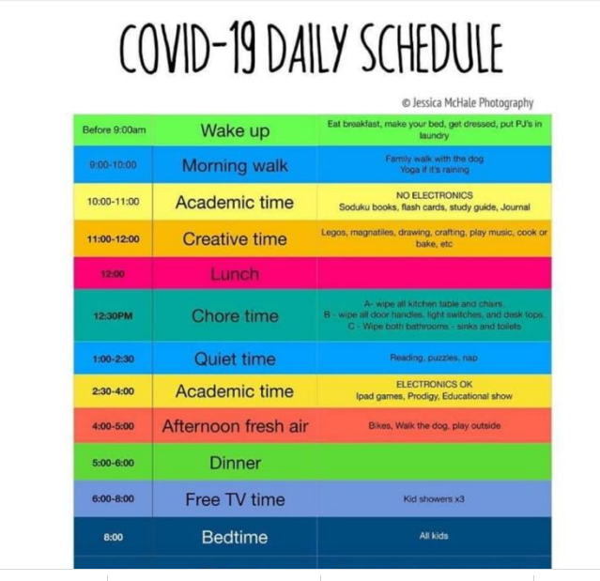



Remember
- To adhere to government guidelines
- Maintain social distance
- Only leave the house if necessary

- Wash your hands for 20 seconds
- Disinfect all areas of household regularly
- We are here to help you get through this, ring your keyworker if you are struggling!
Most importantly
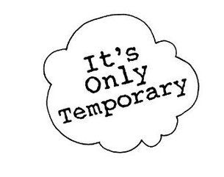
- It is only temporary
- You are doing amazing
- Keep going
- Remain POSITIVE AND FOCUSED
- LOOK AFTER YOURSELF
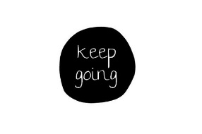
- YOU ARE IMPORTANT!
