**C:\Users\le032647\AppData\Local\Microsoft\Windows\Temporary Internet Files\Content.Outlook\59PMHYA8\Barod-Logo-Pink-WEBSITE.png**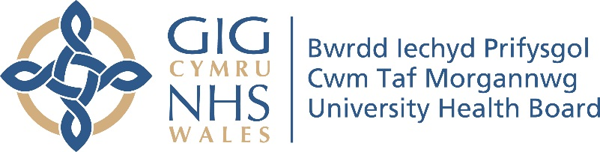

**CWM TAF MORGANWWG INTEGRATED SUBSTANCE MISUSE SERVICE (ISMS)**

**Important advice for DEPENDENT ALCOHOL users during the Coronavirus Pandemic**

If you are self isolating, you may have difficulties buying your usual quantities of alcohol during this time.

If you are dependent on alcohol, you **should not** abruptly stop your alcohol intake. Doing this can cause severe alcohol withdrawal symptoms including seizures which could require hospitalisation.

We all need to reduce the burden on NHS services as much as we can right now, so to reduce the risk of you experiencing an alcohol withdrawal, you may want to think about managing and controlling your alcohol intake wisely.

To help you do this, please consider the following advice.

**Set limits**

Remember being at home you may have more time to yourself, so there could be a temptation to drink more than usual.

Plan your daily alcohol intake, drinking no more than you usually would. Knowing the alcohol units in your drink and making a note of them can be useful. Alternatively, keep track of the quantity of glasses or cans you are consuming. Keeping the bottle tops or ring pulls is useful to keep track.

Don’t drink to get intoxicated, drink enough just to be able to function and carry out your daily living activities. Be aware of safety at home when intoxicated, for e.g, climbing stairs, cooking, using gas/electric appliances.

**Drink lower strength alcohol.**

To reduce the risk of you experiencing acute alcohol withdrawal symptoms, consider switching to a lower strength version of your usual drink. For example if you usually drink Lager at 8.5%, switch to 6.5%, or Wine at 13.5%, switch to 11%. You shouldn’t switch to different types of alcohol, stick to the same type of drink.

**Pace yourself.**

When you drink, pace yourself. Sip slowly. Make every other drink a non-alcoholic one, such as water, tea, squash etc. Try to make one drink last around an hour. Always allow time between consuming one drink before the next. Make sure you eat regular meals/snacks during the day.

**Reducing your intake altogether.**

You may decide to reduce your overall alcohol intake significantly. As before, if you decide to do this, do not cut out alcohol out completely, but use the advice above and speak to your CDAT or Barod keyworker (telephone them, they can ring you back). They will advise you based on your current alcohol intake and pattern.

**Don’t switch to other drugs or stronger alcohol.**

It can be tempting to pick up another drug, if you’re not able to obtain alcohol. Bear in mind that switching drugs carries its own risks such as overdose, and can lead to more problems in the future.

**Storing alcohol safely**

Please keep your alcohol stored safely at home away from children and vulnerable people in your household.

**What to do if you think you have alcohol withdrawal symptoms.**

These usually appear anything between 6 and 72 hrs after the last alcohol drink, so you may experience them first thing in the morning or anytime when drank any alcohol in several hours.

If you start to experience hand tremor or shaking, sweating, anxiety, nausea, palpitations, sip your alcohol until these symptoms subside. Monitor the symptoms to see if you settle and symptoms reduce. If you are unsure, phone your keyworker, GP surgery **Ring NHS Direct Wales (24hrs)** [**0845 46 47**](tel:08454647)**.**

If your alcohol withdrawal symptoms do not reduce on taking alcohol and they get worse, or you develop hallucinations (seeing, hearing or feeling things on your body that are not actually there), confusion, or seizures (fits) or for any other emergency need **Ring 999.**

**Call 999 now if you have any life threatening symptoms:**

* Severe breathing problems (e.g. can’t talk normally, turning blue and gasping)
* Chest pain (e.g. like a tight band or heavy weight in or around the chest)
* Stroke (e.g. unable to raise arm, one sided limb weakness or drooping face)
* Severe injury/heavy bleeding that cannot be stopped
* Fitting now/unconscious (e.g. cannot be woken)

#### **If you also have Coronavirus symptoms, i.e either a high temperature and/or a continuous cough, tell the operator when you ring.**

**Living alone**

If you live alone, ask friends and family to check on you by phoning or messaging you regularly. Ask them to call **Police 101** if they do not get a response, so they can check if you’re safe at home. Keep your mobile phone topped up with credit.

Your CDAT or Barod keyworker and/or DASPA, Drug and Alcohol Single point of Access can give you details on the support networks set up in your local community if you require additional support for your needs, including obtaining supplies, food and medicines. Useful telephone numbers are below.

If you need more information on anything in this letter, please contact your CDAT or Barod keyworker.

CDAT Merthyr Tydfil Keir Hardie Health Park 01685 351189

CDAT Cynon Ysbyty Cwm Cynon, 01443 715110

CDAT Taff Ely Llwyn Yr Eos clinic 01443 443060

CDAT Rhondda Trealaw 01443 443443 ext 75757

CDAT Bridgend Celtic Court 01656 667717

Barod Merthyr Tydfil 01685 721721

Barod Aberdare 01685 880090

If you are affected or concerned by yours or someone else’s substance use please contact our Drug and Alcohol single Point of Access for help and support on

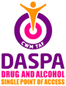

Tel 0300 333 0000

**Stay safe, stay well, stay at home, protect our NHS.**