Mike Parry Art Award 2020

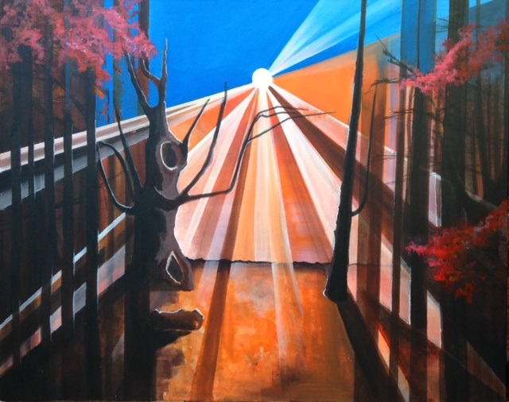

Life in Lockdown:
Art in Isolation

Barod are please to announce the return of the Mike Parry Art Award competition. Mike was one of our colleagues who sadly passed away in January 2019. He was a gifted artist, but he was also a wonderful art teacher. He worked tirelessly with our service users to find their inner Picasso, Van Gogh or Pollock and to enable them to use art as a way to making positive changes, increase their confidence and improve their health and wellbeing. In Mike’s memory, we launched the first art award competition last year in his name. Last year’s winning piece was painted by Emma and can be found on the front cover of this entry form.
Considering the coronavirus pandemic, this year’s theme is based on ‘Life in Lockdown: Art in Isolation’. This theme will capture what people’s experience has been of the coronavirus lockdown. If you have been in substance misuse services, past or present anywhere in Wales, you will be able to enter this year’s competition. We will accept all types of art, from paintings and drawings to sculpture and photography or poetry. There will be a prize for the winning entry within each category and all entries will be displayed at an exhibition in autumn 2020. Please visit https://barod.cymru/mike-parry-art-award-2020/ for further details and T&C’s.
Mike Parry Art Award 2020
Entry Criteria

1. | You must have been in substance misuse services, whether past or present.
2. | Entries submitted can be art of any form, including but not limited to:  - Drawings  - Paintings  - Sculpture  - Photographs  - Poems  - Films (under 10 minutes in length)
3. | All entries must include the following:  - Completed entry form  - A digital photograph and/or copy of your piece  - A narrative, no longer than 250 words, explaining your artwork in line with the theme ‘Life in Lockdown: Art in Isolation’
4. | All sections of the entry form are mandatory unless stated otherwise
5. | All entries must be received by 30th September 2020. Any entries submitted after this date will not be considered. All entries are to be sent to info@barod.cymru
6. | The original piece must be transported to your local Barod base for it to be displayed for an exhibit. How and when the original piece needs to be received by a Barod base, will be confirmed with the person submitting the entry, at a later date.

Mike Parry Art Award 2020
Entry Form
*Please complete all sections unless stated otherwise.
*Name
*Age Group (please select) | Under 18 18 and over
*Category (please select) | Young People (Under 18) Adult Group
*Address | Postcode:
*Contact number
Contact number 2 (optional)
*Email address

*Which substance misuse service are you currently, or previously been, involved in:

In the event of Barod being unable to contact you regarding your entry, are you involved with another service that you consent to us contacting in relation to your entry. Please provide details of the additional contact. | Name of organisation:  Contact number:
*Do you wish your entry to remain anonymous (please select)? | Yes No
Do you consent to your piece being used for illustration purposes only, in line with confidentiality, as part of a report for research carried out by the University of South Wales (please select)? | Yes No
*Would you like your piece to be part of an auction? The funds raised will be donated to an art group of your choice. (Please select) | Yes No  *If your piece is auctioned off, please state which art group you would like the funds raised to be directed to:

*In 250 words or less please explain how the piece of art meets the theme ‘Life in Lockdown: Art in Isolation’:
(Please note this section will be used as part of the scoring process in addition to your art piece)

Please submit your completed entry form along with a digital photograph of your piece to info@barod.cymru. Thank you and good luck!

Disclaimer
By entering this competition, you are confirming that you are happy for Barod to use pictures of your artwork for promotional purposes. This can be done without using your name / full name if preferred.

