Mike Parry Art Award 2021

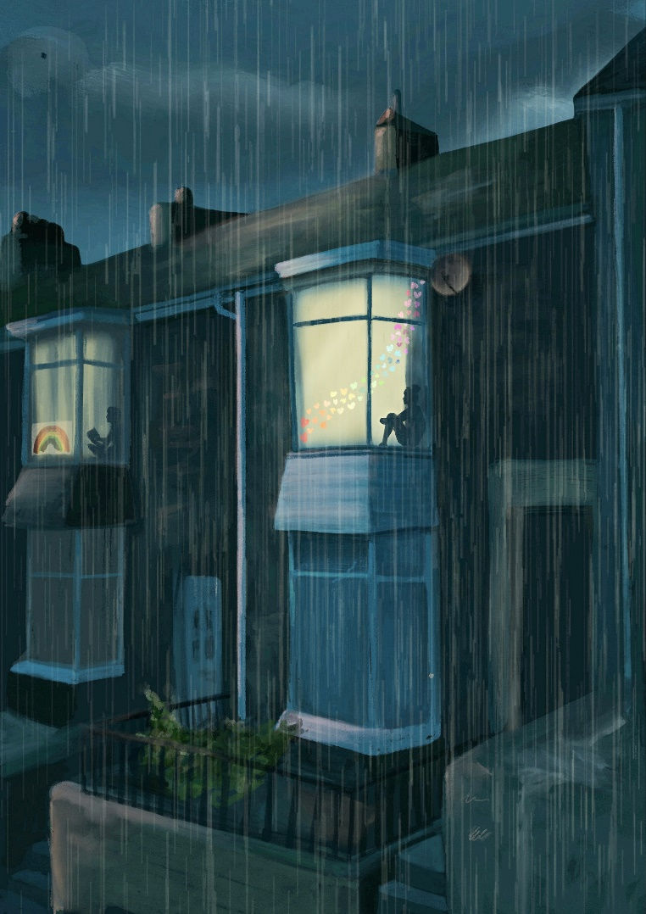

“FREEDOM”

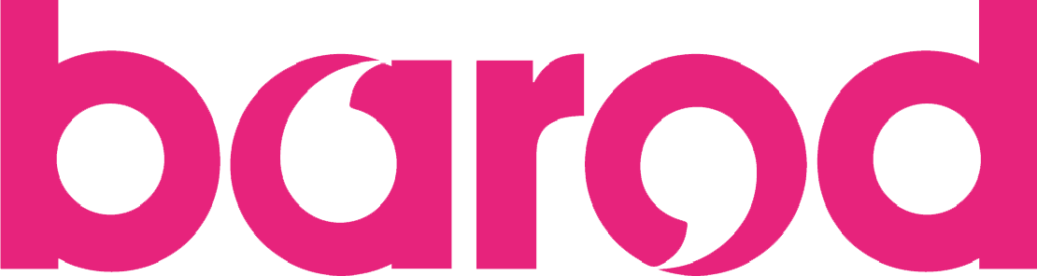
"Mike was my inspiration, what a man!" Dai (2020 entrant)
We are delighted to announce the launch of the Mike Parry Art Award Competition 2021. Mike sadly passed away in January 2019. Mike was a keen artist who influenced many, whether it be picking up a paint brush for the first time or just enjoy art for what it is. In his memory, an art award competition was set up in 2019.
This year's theme is 'FREEDOM' and it is open to interpretation in what you perceive freedom to mean to you. If you have been involved with substance misuse services in Wales, past or present, then you are welcome to enter a piece in this year's competition. We will accept all types of art, from paintings and drawings to sculpture and photography or poetry. Just check out the entry criteria below.
This year we will have three different categories: Young People (up to 18 years old); Adults; and Group, each of which will have their own separate winners. We hope to be able to hold an exhibition in the autumn, where all entries will be displayed. We will also hold a virtual exhibition, just as we did for the 2020 competition. Please visit https://barod.cymru/mpaa2021/ for further details and T&C’s.
Mike Parry Art Award 2021
Entry Criteria

1. | You must have been in substance misuse services, whether past or present.
2. | Entries submitted can be art of any form, including but not limited to:  - Drawings  - Paintings  - Sculpture  - Photographs  - Poems  - Films (under 10 minutes in length)
3. | All entries must include the following:  - Completed entry form  - A digital photograph and/or copy of your piece  - A narrative, no longer than 250 words, explaining your artwork in line with the theme ‘FREEDOM’
4. | All sections of the entry form are mandatory unless stated otherwise
5. | All entries must be received by 30th September 2021. Any entries submitted after this date will not be considered. All entries are to be sent to info@barod.cymru.
6. | The original piece must be transported to your local Barod base for it to be displayed for an exhibit. How and when the original piece needs to be received by a Barod base, will be confirmed with the person submitting the entry, at a later date.

Mike Parry Art Award 2021
Entry Form
*Please complete all sections unless stated otherwise.
*Name
*Age Group (please select) | Under 18 18 and over
*Category (please select) | Young People (Under 18) Adult Group
*Address | Postcode:
*Contact number
Contact number 2 (optional)
*Email address

*Which substance misuse service are you currently, or previously been, involved in:

In the event of Barod being unable to contact you regarding your entry, are you involved with another service that you consent to us contacting in relation to your entry. Please provide details of the additional contact. | Name of organisation:  Contact number:
*Do you wish your entry to remain anonymous (please select)? | Yes No
*Do you consent to your piece being used for illustration purposes only, in line with confidentiality, as part of any Barod-related materials, resources or promotional purposes, such as being used on our social media or website, that is unrelated to the Mike Parry Art Award? | Yes No
*Would you like your piece to be part of an auction? The funds raised will be directed to an art group of your choice. (Please select) | Yes No  If your piece is auctioned off, please state which art group you would like the funds raised to be directed to:
If you answered 'yes' to your piece being part of the auction, please provide the dimensions of your piece - length x width (x depth).
If there are no specific dimensions (e.g. because it is in a digital format), please state what format your piece is in.

*In 250 words or less please explain how the piece of art meets the theme ‘FREEDOM’:
(Please note this section will be used as part of the scoring process in addition to your art piece)

Please submit your completed entry form along with a digital photograph of your piece to info@barod.cymru. Thank you and good luck!

