Mike Parry Art Award 2025

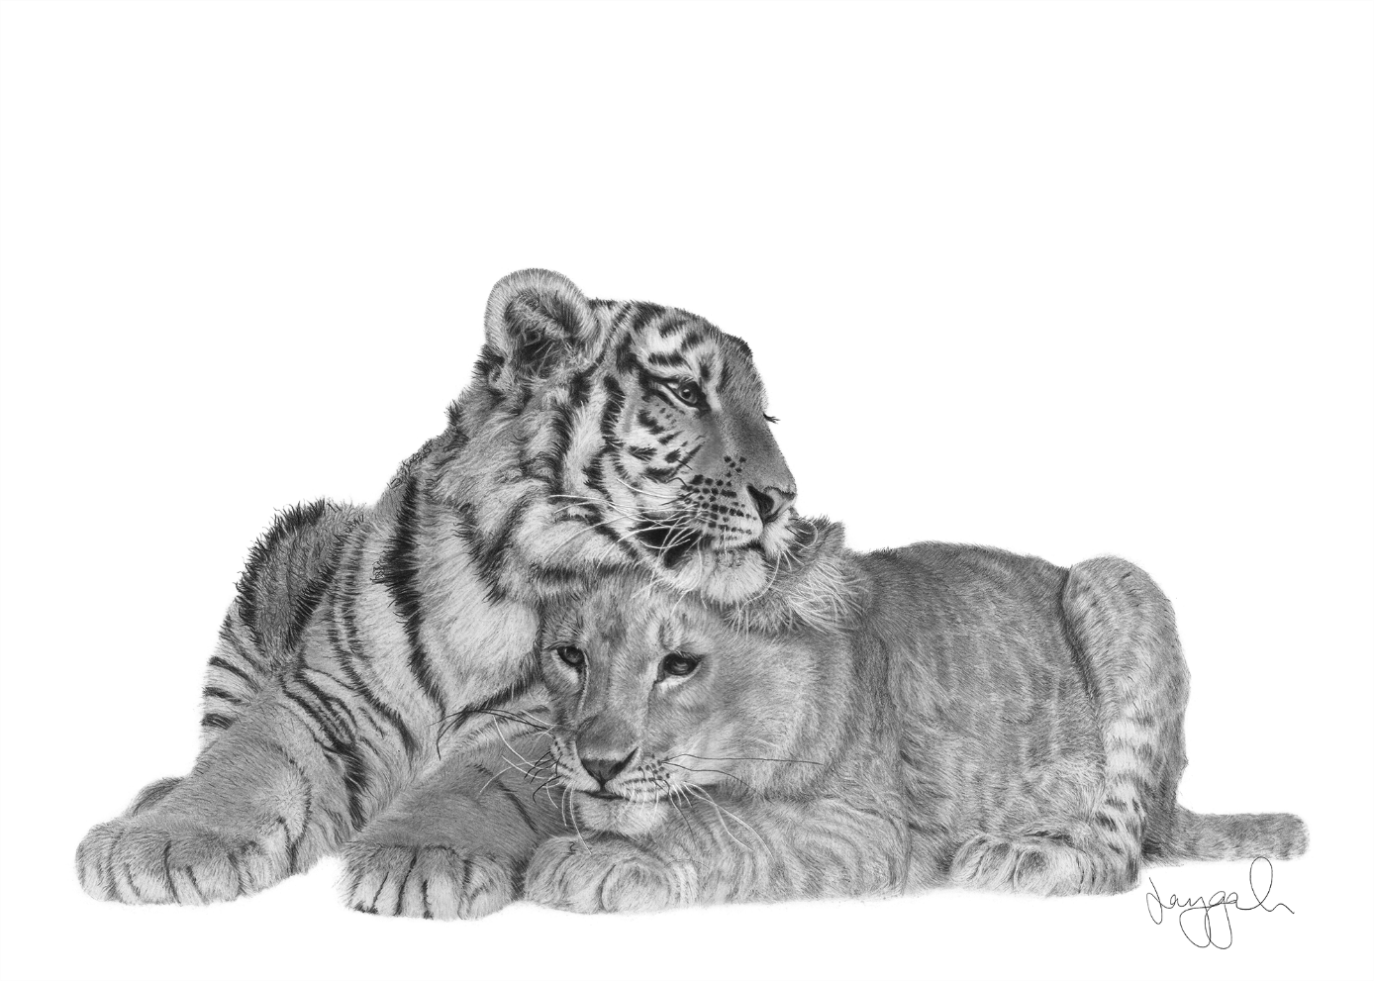

“FUTURE”

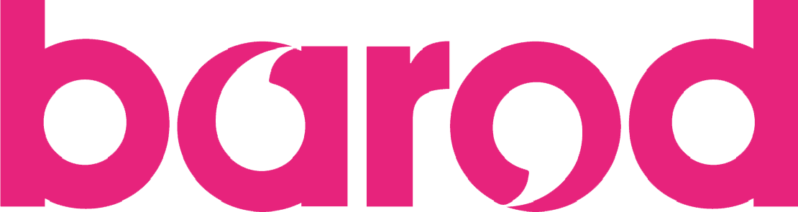
We are delighted to announce the launch of the Mike Parry Art Award Competition 2025. Mike sadly passed away in January 2019. Mike was a keen artist who influenced many, whether it be picking up a paint brush for the first time or just enjoy art for what it is. In his memory, an art award competition was set up in 2019.
This year's theme is 'FUTURE' and it is open to interpretation in what you perceive future to mean to you. If you have been involved with substance use services in Wales, past or present, then you are welcome to enter a piece in this year's competition. We will accept all types of art, from paintings and drawings to sculpture and photography or poetry. Just check out the entry criteria, available below.
This year we will have three different categories: Young People (up to 18 years old); Adults; and Group, with first place of each category winning up to £100 in vouchers. There will also be 2nd and 3rd place prizes.
For more information, please visit https://barod.cymru/artaward2025/.



Mike Parry Art Award 2025
Entry Criteria

1. | You must have been in substance use services, whether past or present.
2. | Entries submitted can be art of any form, including but not limited to:  - Drawings  - Paintings  - Sculpture  - Photographs  - Poems  - Films (under 10 minutes in length)
3. | All entries must include the following:  - Completed entry form.  - A digital photograph and/or copy of your piece.  - A narrative, no longer than 250 words, explaining your artwork in line with the theme ‘FUTURE’. It is up to you in relation to your interpretation of future and what this means to you.
4. | All sections of the entry form are mandatory unless stated otherwise
5. | All entries must be received by Friday 25th April 2025. Any entries submitted after this date will not be considered. All entries are to be sent to info@barod.cymru or via our dedicated Google form, that can be accessed by clicking here.

Mike Parry Art Award 2025
Entry Form
*Please complete all sections unless stated otherwise.
*Name
*Group (please select) | Young People (Under 18) Adult Group
*Address | Postcode:
*Contact number
Contact number 2 (optional)
*Email address

*Which substance use service are you currently, or previously been, involved in:

In the event of Barod being unable to contact you regarding your entry, are you involved with another service that you consent to us contacting in relation to your entry. Please provide details of the additional contact. | Name of organisation:  Contact number:
*Do you wish your entry to remain anonymous (please select)? | Yes No
*Do you consent to your piece being used for illustration purposes only, in line with confidentiality, as part of any Barod-related materials, resources or promotional purposes, such as being used on our social media or website, that is unrelated to the Mike Parry Art Award? | Yes No

*In 250 words or less please explain how the piece of art meets the theme ‘FUTURE’:
(Please note this section will be used as part of the scoring process in addition to your art piece)

Please submit your completed entry form along with a digital image of your piece to info@barod.cymru. Thank you and good luck!

